**DocCheck**

A project report submitted to the University of Calicut

In partial fulfilment of the requirement for the award of the degree of

Bachelor of Computer Science

By

Gopika. M (MEAPSCS020)

Shasliya.V (MEAPSCS022)

Shifana. E (MEAPSCS023)

Amina Minusha (MEAPSCS024)

*Under the Guidance of*

Mrs. Rababa Kareem. K

(Asst. Professor of Computer Science, Dept. of Computer Science)



Sullamussalam Science College, Areecode

Ugrapuram(P.O), Malappuram-673639

March 2018

PROJECT REPORT

DocCheck-Doctor’s Online Booking System

Submitted by

Gopika. M (MEAPSCS020)

Shasliya.V (MEAPSCS022)

Shifana. E (MEAPSCS023)

Amina Minusha (MEAPSCS024)

In partial fulfillment of requirement for the award of

**BSc Computer Science**

University of Calicut

2017-2018

**Sullamussalam Science College, Areacode**

Ugrapuram(P.O), Malappuram-673639

March -2018



**CERTIFICATE**

This is to hereby certify that the project work entitled “Doctor’s Online Booking System have been carried out by Gopika.M(MEAPSCS020), Shasliya.V(MEAPSCS022)**,** Amina Minusha (MEAPSCS024), Shifana.E (MEAPSCS023) of sixth semester computer science, under my guidence submitted in partial fulfilment of the requirement of BSc Computer Science during the period of 2017-2018 of Calicut university.

Further it is certified that, to the best of my knowledge, the matter embedded in this work has not been submitted for the award of any other degree.

T.P.O Ashrafali

(Head, Department of computer Science)

Sullamussalam Science College, Areacode

Date ........................



**APPROVAL**

The project entitled “Doctor’s Online Booking System” here by approved as a credible study of BSc Computer Science subject has been carried out by Gopika.M (MEAPSCS020), Shasliya.V (MEAPSCS022)**,** Amina Minusha (MEAPSCS024), Shifana.E (MEAPSCS023) and presented in satisfactory manner to warrant its acceptance as a prerequisite to the degree of BSc Computer Science.

Internal Project Guide

Mrs. Rababa kareem

Dept. of Computer Science

External Examiners:

1.

2.

**DECLARATION**

We hereby declare that the project work entitled “Doctor’s Online Booking System” is a record of original work carried out by us under the guidance of Mrs. Rababa Kareem (Dept of Computer Science, SS College, Areecode). The project report is submitted to the partial fulfilment of the requirement of BSc Computer Science during the period of study at Sullamussalam Science college, Areecode.

Gopika.M

Shifana.E

Shasliya.V

Amina Minusha

**ACKNOWLEDGEMENT**

We, Gopika. M, Shasliya. V, Amina Minusha, Shifana. E takes the opportunity to express our sincere thanks and gratitude to all who have contributed towards the successful completion of our project.

Also, we express our sincere gratitude to all our teachers and friends for extending the valuable advice, help and valuable suggestions to bring our project into reality.

Last but not least, our family members, for their blessings and support. We are extremely grateful to the Almighty who bestowed us with courage and strength to complete this project successfully.

With Sincere Thanks,

Amina minusha

Shasliya.V

Shifana.E

Gopika.M

CONTENTS

|  |  |
| --- | --- |
| TITLES | PAGE NO |
| 1. INTRODUCTION |  |
| 1.1 PROJECT PURPOSE |  |
| * 1. SCOPE OF THE PROJECT |  |
| 1. SYSTEM ANALYSIS |  |
| 2.1 SYSTEM STUDY |  |
| 2.1.1 IDENTIFICATION OF NEED |  |
| 2.1.2 PROPOSED SYSTEM |  |
| 2.1.3 FUNCTIONAL REQUIREMENTS |  |
| 2.2 SYSTEM ANALYSIS |  |
| 2.3 FEASIBILITY STUDY |  |
| 2.3.1 TECHNICAL FEASIBILITY |  |
| 2.3.2 ECONOMIC FEASIBILITY |  |
| 2.3.3 OPERATIONAL FEASIBILITY |  |
| 2.4 SYSTEM REQUIREMENTS |  |
| 2.4.1 SOFTWARE REQUIREMENTS |  |
| 2.4.2 HARDWARE REQUIREMENTS |  |
| * + 1. TECHNOLOGY SPECIFICATION |  |
| 1. SYSTEM DESIGN |  |
| * 1. DESIGN PHASE |  |
| 3.1.1 LOGICAL PHASE |  |
| 1. DFD |  |
| 3.1.2 PHYSICAL DESIGN |  |
| 3.1.3 INPUT DESIGN |  |
| 3.1.4 DATABASE DESIGN |  |
| 1. TABLE DESIGN |  |
| 3.1.5 OUTPUT DESIGN |  |
| 1. IMPLEMENTATION AND TESTING |  |
| 4.1 IMPLEMENTATION |  |
| 4.2 TESTING |  |
| 1. WHITE BOX TESTING |  |
| 1. BLACK BOX TESTING |  |
| 1. INTEGRATION TESTING |  |
| 1. VALIDATION TESTING |  |
| 1. SYSTEM TESTING |  |
| 4.3 TEST PLAN |  |
| 1. MAINTAINENCE AND PLANNING |  |
| 5.1 WEBSITE MAINTAINANCE |  |
| 5.2 SYSTEM PLANNING |  |
| 1. OVERVIEW |  |
| 1. CONCLUSION |  |
| 1. REFERENCE |  |

**INTRODUCTION**

1. **INTRODUCTION**

**1.1 PROJECT PURPOSE**

The purpose of the project is to help the public. It gives the opportunities to book doctors online and for doctors, detailed section for updating has been provided.

**1.2 SCOPE OF THE PROJECT**

The proposed project is a smart appointment booking system that provides patients or any user an easy way of booking a doctor’s appointment online. This is an android based application that overcomes the issue of managing and booking appointments according to user’s choice or demands. The task sometimes becomes very tedious for the compounder or doctor himself in manually allotting appointments for the users as per their availability. Hence this project offers an effective solution where users can view various token numbers allotted by doctors.

**SYSTEM ANALYSIS**

1. **SYSTEM STUDY AND ANALYSIS**

**2.1 SYSTEM STUDY**

2.1.1 IDENTIFICATION OF NEED

I identified that most of the patients are waiting for op ticket for a long time. It is difficult to both patients and hospitals. It is time consuming process.

* + 1. PROPOSED SYSTEM

Proposed system will overcome the drawbacks of existing system. The proposed system has many advantages. Simple and user friendly application for the smartphone users. In proposed system we have notifications send by the doctors which can be accessed by the patients. The system provides helps to both hospitals and patients. For the system admin they can add their details with services they provide. They can add their doctors other facilities. By approving administrator it is added to the application. For patients they can book doctors as their needs from available list. The system provide to both doctors and patients to add details and book doctor respectively at any time. Even the short notices given by the doctors can by a patient. If a doctor is not available at a particular day the doctor can post his leave as notification and the patients can see the notification and can consume his/her time by not going to the hospital . Everything is available at a tap of your fingers

2.1.3 FUNCTIONAL REQUIREMENTS

* Admin login
* User login
  + Patients
  + Doctors
* For doctors
  + View patient booking details
  + Provide timeslot available
  + Add details to profile
* For patients
  + Booking option
  + Searching doctors by name/specialization
  + Get notification as short notice
  + View all bookings through the app as history

**MODULE DESCRIPTION**

There are basically two modules in this project

* Admin module
* User module

**Admin module**

* Overall control of the system.
* Can login username and password.
* Add new details.
* View all details.
* Update and delete details.

**User module**

* **Patients** 
  + **View doctors details**
  + **Reservation option**
  + **Notifications**
* **Doctors**
  + **Number of patients booked**
  + **Notifications**

**2.2 SYSTEM ANALYSIS**

System analysis involves the requirement determination and specification. Basically, it involves establishing requirements for all system elements and the mapping these requirements to the software forms. The analysis intented to capture and describe all the requirements of the system and to make a model that defines the key domain classes in the system. The purpose is to provide an understanding and enable a communication about the system between the developers and the people establishing the requirements. Therefore the analysis is typically conducted in cooperation with the user/administrator.

System analysis is the detailed study of the various operations performed by a system and the relationship within outside of the system. It helps to understand the problems and emphasizes what is need from the system.

**2.3 FEASIBILITY STUDY**

2.3.1 TECHNICAL FEASIBILITY

The project requires the system to be functional and multi-user one. It should be based on specific technology. The platform that is needed for the development of this system is PHP.

2.3.2 ECONOMIC FEASIBILITY

The given system can be developed under optimal expenses with the available hardware and software. The resources needed to run the project should be less in cost and highly reliable so that there might be no hanging and minimum level of expense to implement the software.

2.3.3 OPERATIONAL FEASIBILITY

It needs less human effort. Administrator has the overall control and the users can directly use the system. So the system can be judged operational.

**2.4 SYSTEM REQUIREMENTS**

The main purpose of the software system specification is the clear definition and specification of functionality and of the software product. It allows the developer to carried out performance level to be obtained and corresponding interface to be established.

2.4.1 SOFTWARE REQUIREMENTS

Front end -Android

Back end -MySQL server

Web server -WampServer

Operating system -Windows

2.4.2 HARDWARE REQUIREMENTS

RAM - 500MB

INTERNAL STORAGE - 50MB

ANDROID VERSION -Ice Cream Sandwitch (minimum)

2.4.3 TECHNOLOGY SPECIFICATION

PHP :

PHP is a general purpose server-side scripting language that was originally designed for web development to produce dynamic web pages.

Main features of PHP are:

* Developer productivity
* Administration and management
* Flexible extensibility
* Performance and scalability

ANDROID :

Android is a mobile operating system developed by Google. It is used by several smartphones and tablets. The Android operating system (OS) is based on the Linux kernel.

Main features of ANDROID are:

• Messaging

• Web

• Browser

• Voice-based features

• Multi-touch

• Multitasking

• Screen capture

• TV recording

• Video calling

• Multiple language support

• Accessibility

SQL:

The structured Query Language (SQL) comprises one of the fundamental building blocks of modern database architecture. SQL is an ANSI (American National Standards Institute) standards computer language for accessing and manipulating database systems. SQL statements are used to retrieve and update data in a database. SQL works with database programs like MS Access, Oracle, DB2, Informix, MS SQL Server and Sybase etc.

A database most often contains one or more tables. Each table is identified by a name (E.g. “Customer” or “Orders”). A table contains record (rows) with data. With SQL we can query a database and have a result set returned. SQL is the syntax for executing queries. But the SQL language also includes the syntax to insert and delete records. These query and update commands together form the Data Manipulation Language (DML) part of SQL. The Data Definition Language (DDL) part of SQL permits database tables to be created or detected. We can also define indexes (keys), specify links between tables and imposes constraints between databases.

SYSTEM DESIGN

1. **SYSTEM DESIGN**

Design is the first step in the development phase for any engineered product or system. It may be defined as the process of applying various techniques and principles for the purpose of defining a process or system in sufficient detail to permit its physical realization. After system analysis, we have clear-cut idea of system. In order develop the proposed system, we have to consider many views and behavior of the system. Here we develop a base plan based on these properties of the system. For that we develop algorithms and flowcharts to signify the system. Then the physical entities in the system, the flow of the data and transfer of the control are represented by data flow diagram.

**3.1 DESIGN PHASES**

3.1.1 LOGICAL PHASE

1. DFD: DFD are a well-known and widely used notation for specifying the functions of an information system. A DFD represents the flow of data. They describe systems as collections of data that are manipulated by functions. Data can be organized in several ways. The can be stored in data repositories, the can flow and can be transferred to or from the external environment.
2. The information flow is gathered on time consuming basis.
3. Control information is passed throughout the system and associated with control processing.
4. System status and the mechanism that causes transition between states.

Rules for constructing a DFD:

1. Arrows should not cross each other.
2. Squares, circles and files must bear names.
3. Composed data flow squares & circles can have same names.
4. Choose meaningful names for data flow.
5. Draw all data flows around the outside of the diagram.

Level 0:-

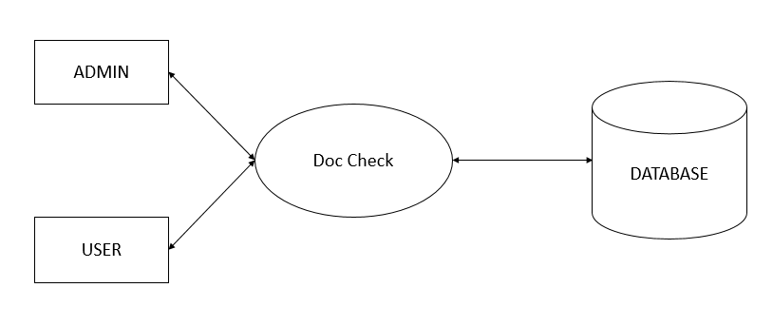

Level 1.1:-

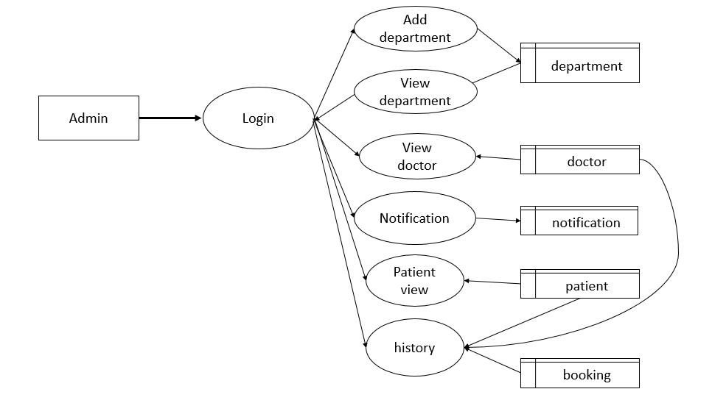

Level 1.2:-

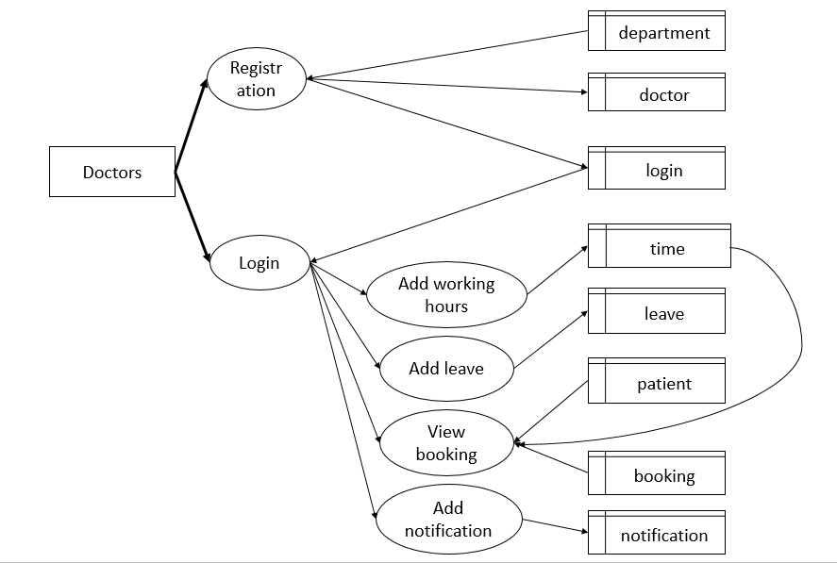

Level 1.3:-

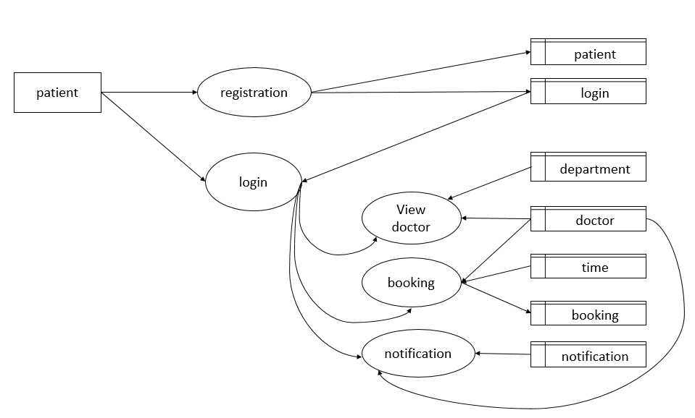

3.1.2 PHYSICAL DESIGN

The physical design produces the working system by defining the design specifications that tell programmer exactly what the candidate system must do. A main stage method in physical design is the input and output design.

3.1.3 INPUT DESIGN

It is the process of converting the user-oriented inputs in the computer base format. The goal of designing input data is to make the automation as easy and free from errors as possible. For providing a good input design for the application, easy data input and selection features are adopted.

The input design requirements such as user friendliness, consistent format and interactive dialogue for giving the right message and help to the user at right time are also considered for the development of the project.

There are 6 objectives of the input design, they are:

1. Effectiveness
2. Accuracy
3. Easy to use
4. Consistency
5. Simplicity
6. Attractiveness

3.1.4 DATABASE DESIGN

The backbone of the system depends upon the database management system. The database related must be reliable and must be protected against unauthorized access. We have chosen MySQL server as the database.

DBMS allows the data to be protected and organized separately from other resources. It also provides recovery facilities privacy control and specific data accessing language to be used by the program. The main objectives of DBMS are data accessibility, data consistency, and data integrity and data independence.

The general theme behind a database is to handle information as an integrated whole. A database is a collection of interrelated data stored with minimum redundancy to serve many users quickly and efficiently. The general objectives are to make information access easy, quick, independence, and flexible for the user.

i. TABLE DESIGN

***TABLE NAME: LOGIN***

***DESCRIPTION: USER LOGIN ACCOUNT DETAILS***

***PRIMARY KEY: ID***

|  |  |  |
| --- | --- | --- |
| Field name | Data type | Constraints |
| id | int | Primary key,  Auto increment |
| Username | varchar | Not null |
| Password | varchar | Not null |
| Type | varchar | Not null |

***TABLE NAME: BOOKING***

***DESCRIPTION: DETAILS OF BOOKING***

***PRIMARY KEY: BID***

|  |  |  |
| --- | --- | --- |
| Field name | Data type | constraints |
| Bid | int | Primary key,autoinc |
| Tid | int | Not null |
| Pid | int | Not null |
| Cur_date | Date | Not null |

***TABLE NAME: DOCTOR***

***DESCRIPTION: DOCTOR DETAILS***

***PRIMARY KEY: DID***

|  |  |  |
| --- | --- | --- |
| Field name | Data type | constraints |
| did | int | Primary key,  Auto increment |
| name | varchar | Not null |
| hospital | varchar | Not null |
| dep_id | int | Not null |
| experience | int | Not null |
| Email_id | varchar | Not null |
| Phone_no | int | Not null |
| Log_id | int | Not null |
| Reg_id | int | Not null |

***TABLE NAME: TIME***

***DESCRIPTION: ALOTTED TIME FOR PATIENT’S***

***PRIMARY KEY: TID***

|  |  |  |
| --- | --- | --- |
| Field name | Data type | Constraints |
| Tid | int | Primary key,  Auto increment |
| Did | int | Not null |
| Start | Time | Not null |
| End | Time | Not null |
| Date | Date | Not null |
| pcount | int | Not null |

***TABLE NAME: DEPARTMENT***

***DESCRIPTION: LIST OF DEPARTMENTS***

***PRIMARY KEY: DEPID***

|  |  |  |
| --- | --- | --- |
| Field name | Data type | Constraints |
| depid | int | Primary key,  Auto increment |
| department | int | Not null |

***TABLE NAME: PATIENT***

***DESCRIPTION: PATIENT DETAILS***

***PRIMARY KEY: PID***

|  |  |  |
| --- | --- | --- |
| Field name | Data type | constraints |
| pid | Int | Primary key,  Auto increment |
| Name | Varchar | Not null |
| age | Int | Not null |
| Phone_no | Int | Not null |
| place | varchar | Not null |
| Log_id | Int | Not null |

***TABLE NAME: LEAVE***

***DESCRIPTION: DOCTOR’S LEAVE DETAILS***

***PRIMARY KEY: LID***

|  |  |  |
| --- | --- | --- |
| Field name | Data type | Constraints |
| Lid | Int | Primary key,  Auto increment |
| Did | Int | Not null |
| Date | Date | Not null |

***TABLE NAME: NOTIFICATION***

***DESCRIPTION: NOTIFICATIONS SET BY DOCTORS***

***PRIMARY KEY: NID***

|  |  |  |
| --- | --- | --- |
| Field name | Data type | Constraints |
| Nid | Int | Primary key,  Auto increment |
| Notification | varchar | Not null |
| Date | Date | Not null |
| Did | Int | Not null |

**IMPLEMENTATION & TESTING**

1. **IMPLEMENTATION AND TESTING**

**4.2 TESTING**

Test cases are developed using various test techniques to achieve more effective testing. By this, software completeness is provided and conditions of testing which get the greatest probability of finding errors are chosen. So, testers do not guess which test cases to choose, and test techniques enable them to design testing conditions in a systematic way. Also, if one combines all sorts of existing test techniques, one will obtain better results rather if one uses just one test technique.

Software can be tested in two ways, in another words, one can distinguish two different methods:

1. Black box testing, and

2. White box testing.

**i. WHITE BOX TESTING**

***White box testing*** is highly effective in detecting and resolving problems, because bugs can often be found before they cause trouble. We can shortly define this method as *testing software with the knowledge of the internal structure and coding inside the program*. White box testing is also called white box analysis, clear box testing or clear box analysis.

***Debugging*** in which the tester has excellent knowledge of how the program components interact. This method can be used for Web services applications, and is rarely practical for debugging in large systems and networks.

1. **BLACKBOX TESTING**

***Black box testing*** *is testing software based on output requirements and without any knowledge of the internal structure or coding in the program*. In another words, a black box is any device whose workings are not understood by or accessible to its user. It is attempted to find errors in the following categories, incorrect or missing function, interface errors. Errors in the data structures or external database access

1. Performance errors

2. Initialization errors

These are corrected in every module. The first module is tested and there are any missing functions or other interface errors then they are rectified. Then the testing is done on the second module similarly are tested.

1. **UNIT TESTING**

Unit Debugging in which the tester has excellent knowledge of how the program components interact. This method can be used for Web services applications, and is rarely practical for debugging in large systems and networks.

In unit testing, module interface is tested to ensure that information properly flows into and put of the program under test. Local data structures are examined to ensure that data stored temporarily maintains its integrity during all steps in algorithm execution. Boundary condition is tested to ensure that the module operates properly and at boundaries established to limit or restrict processing. All independent paths throw the control structures are executed to ensure that all statement in the module have been executed at least once. Error handling paths are also tested.

This test focuses verification effort of the smallest unit of software design, the module. Here, the module interfaces, local data structure, boundary conditions, and all independent paths were verified by inputting false data. Tests of data flow across each module interface of this website where done before any other test was initiated.

1. **INTEGRATION TESTING**

It is a systematic technique for constructing the program structure while at same time conducting testes to uncover errors associated with interfacing. Unit tested module were taken and a single programme structure was build that has been dictated by the single program structure was build that has been dictated by the design. Incremental integration has adopted here. The entire software was developed and testing in small segments, where errors were easy to locate and rectify. Program builds were constructed corresponding to the successful testing of user interaction, Data manipulation analysis and display processing and database management. These tests can also the performed.

1. Top down interaction
2. Bottom up interaction
3. **VALIDATION TESTING**

It is done to ensure complete assembly of the error ***free website. Validation can be termed successful only if*** it functions in manner.

Reasonable expected by the customer under validation is alpha and beta testing. Alpha testing is where the end user tests the system rather than the developer, but in a controlled environment. The website is used on a natural setting with developer monitoring the user using the system the developer record the errors and usage problems encoded by the user.

1. **SYSTEM TESTING**

It is actually a series of different test whose primary purpose to fully exercise the web based system. Each test works to verify that all system tests are:

1. Recovery testing
2. Security testing
3. Stress testing
4. Performance testing

All the above testing’s are being done and seen that it is properly integrated and software is checked whether it is in working state.

**4.3 TEST PLAN**

The proposed project has undergone the formal process of independent in the same manner as is every other system would undergo. The test plan was designed to test quality of the system.

* ***UNIT TESTING***

For each module these test cases are implemented and it is checked whether the modules is executed as per the requirement and output the desired result.

* ***INTEGRATION TESTING***

The modules are tested separately for accuracy and modules are integration is rectified.

* ***VALIDATION TESTING***

Entering incorrect values does the validation test and it is checked whether the errors are being considered. Incorrect values are to be discarded. The errors are rectified.

* ***SYSTEM TESTING***

It was performed to verify that all system elements have been properly integrated and performed allocated function.

Security testing was done to check the security mechanisms build in to the system, which will protect it from improper penetration; performance testing was done to test the run time performance of the system. For user acceptance testing, the system was given to the end-user to use. The error found was rectified.

**MAITENANCE & PLANNING**

**5. MAINTENANCE AND PLANNING**

* 1. **WEBSITE MAINTENANCE**

Once the system is delivered and deployed, it enters the maintenance phase. All systems need maintenance, but for other systems it is largely due to problems that are introduced due to aging. It needs to be maintained not because of some of its components wear out and need to be replaced, but because there are often some residual error remaining in the system that must be removed as they are discovered. These errors, once discovered, need to be removed, leading to the software getting changed. This is sometimes called “Corrective maintenance”.

* 1. **SYSTEM PLANNING**

Developing a system requires planning and coordinating resources within a given time. The process of planning and implementing computer system called a project. Just like large projects, planning and installing smaller projects on schedule also take time and require control and coordination of resources.

Without planning, it is difficult to measure progress. As plan are crystalized crisis should being to disappear. Project involves plotting project activities against a time frame. One of the first steps in project planning is developing a roadmap structure network based on analysis of the tasks that must be performed to complete the project.

**SCREEN LAYOUTS**

**6.OVERVIEW**

ADMIN PAGE

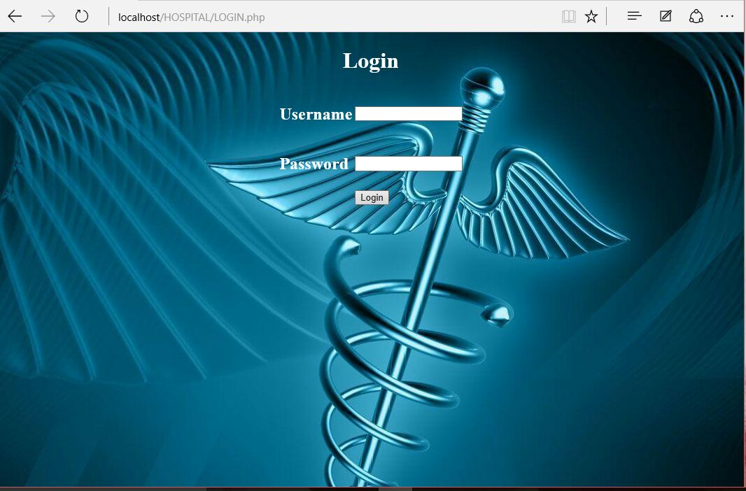

DocCheck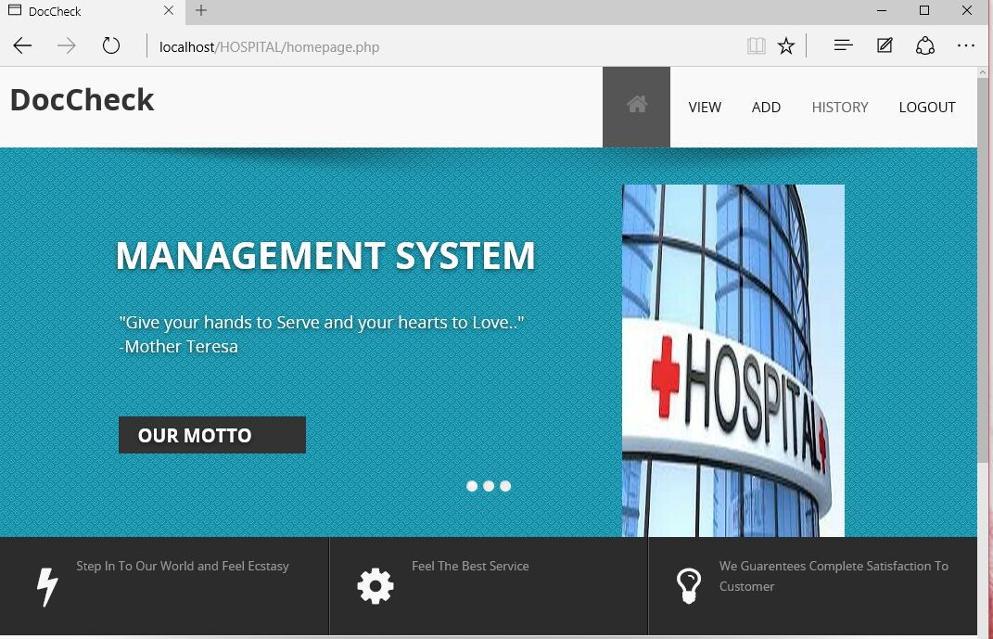

DOCTORS LIST

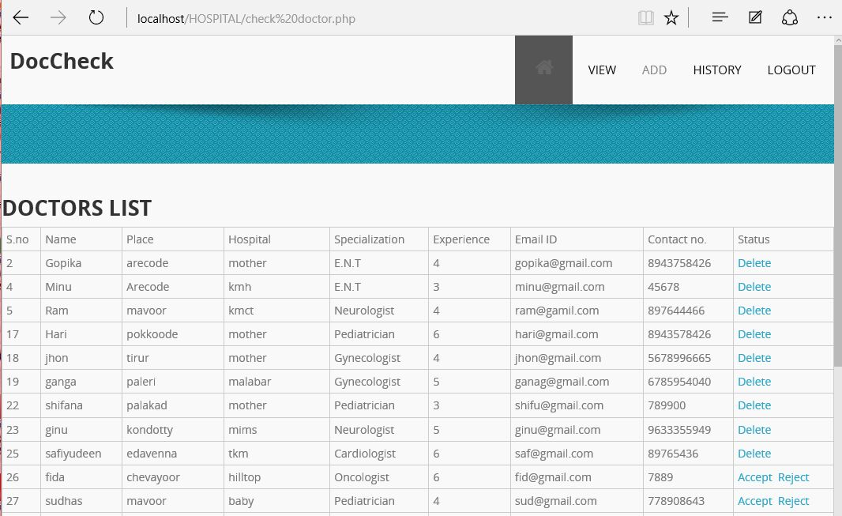

VIEW PATIENT

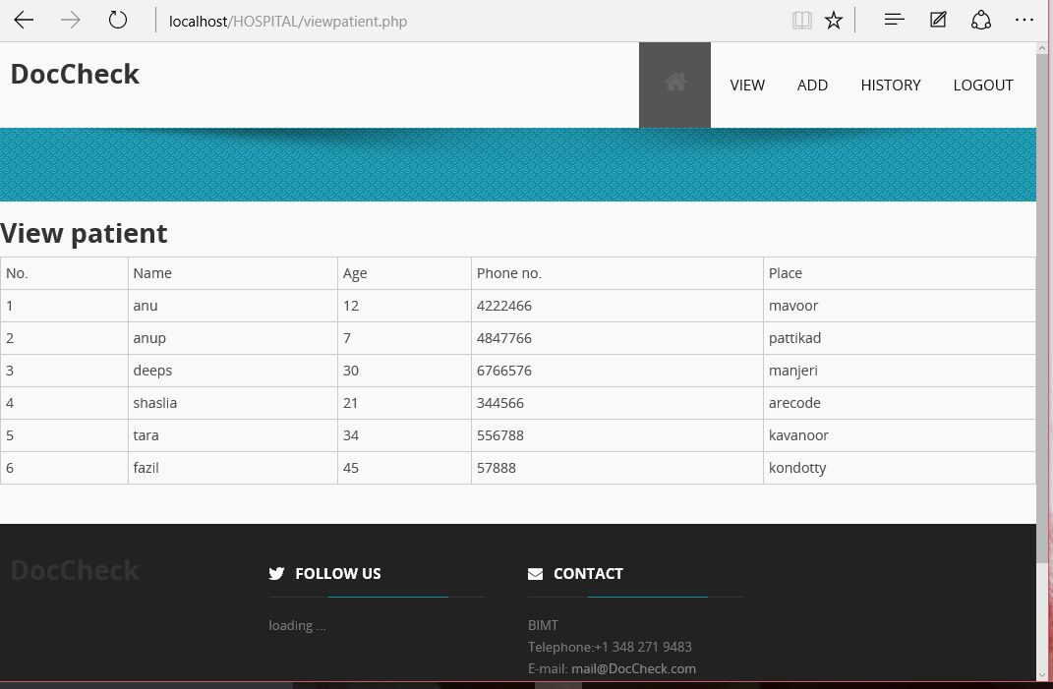

BOOKING DETAILS

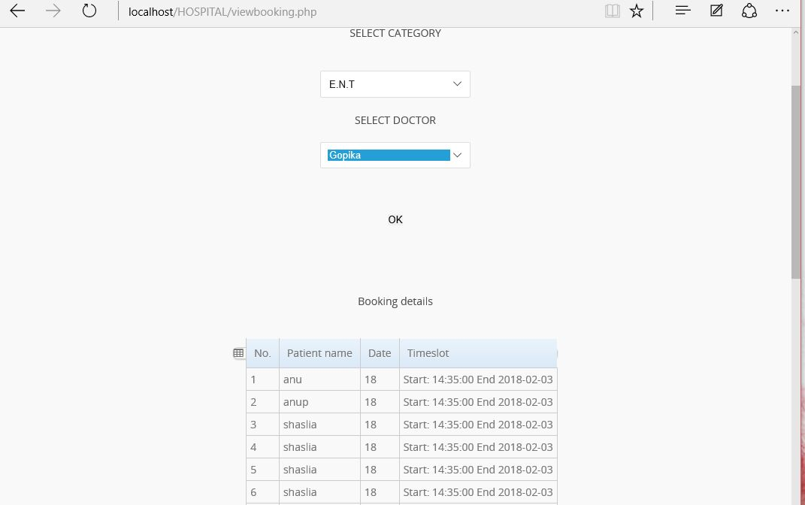

DEPARTMENT LIST

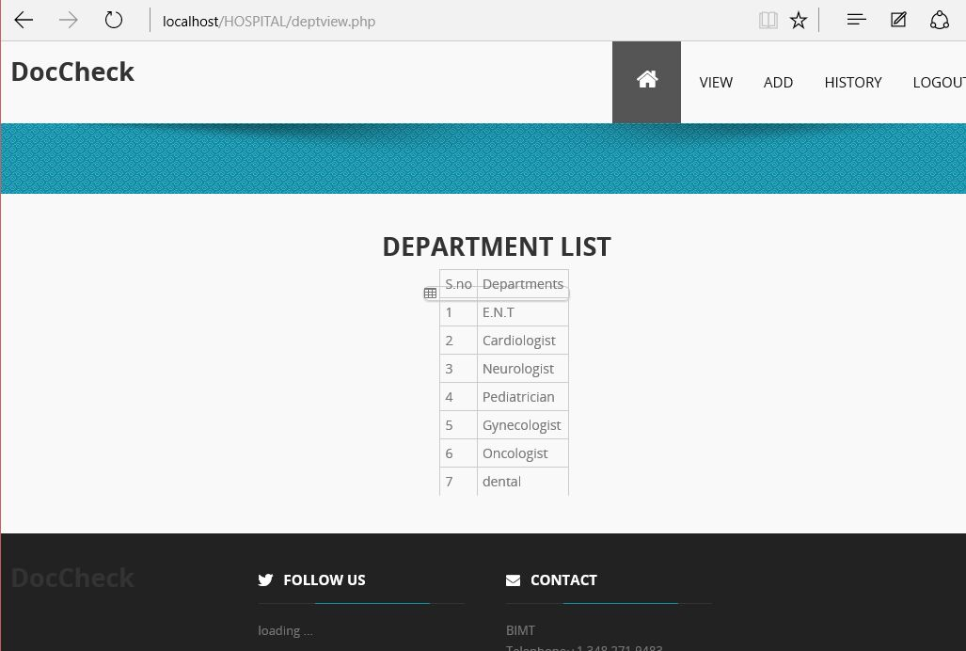

ADD DEPARTMENT

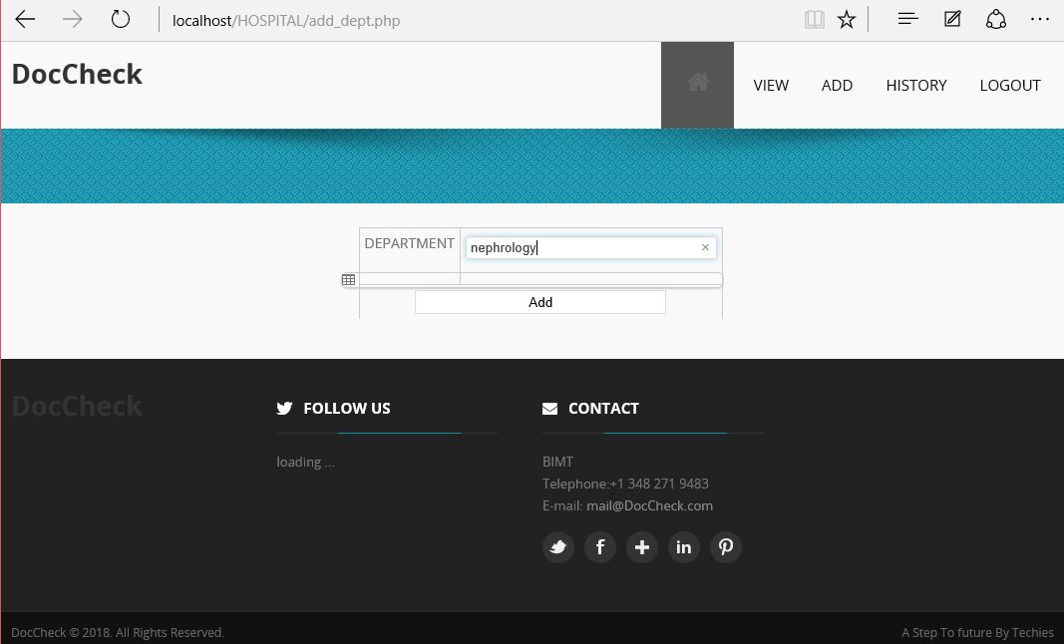

HISTORY

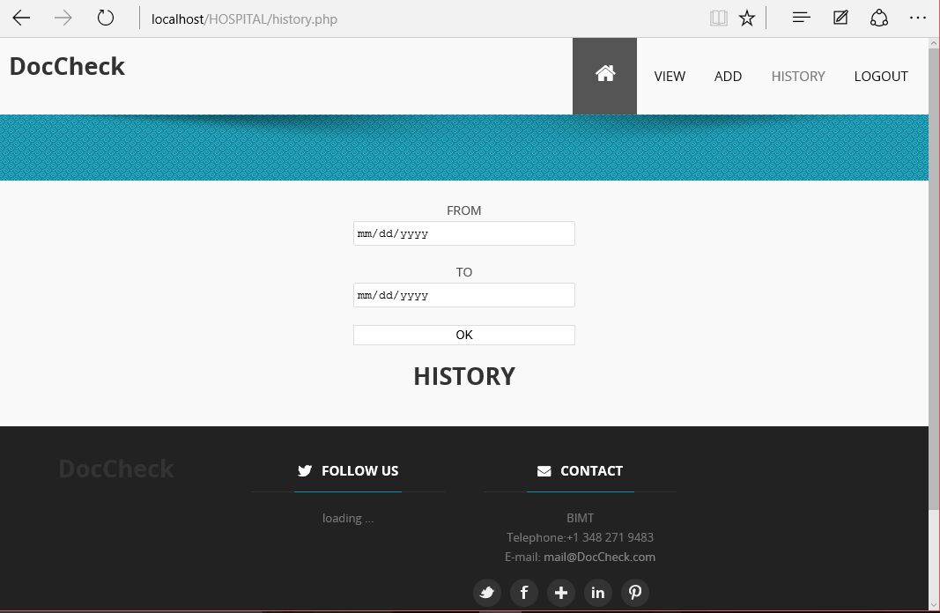

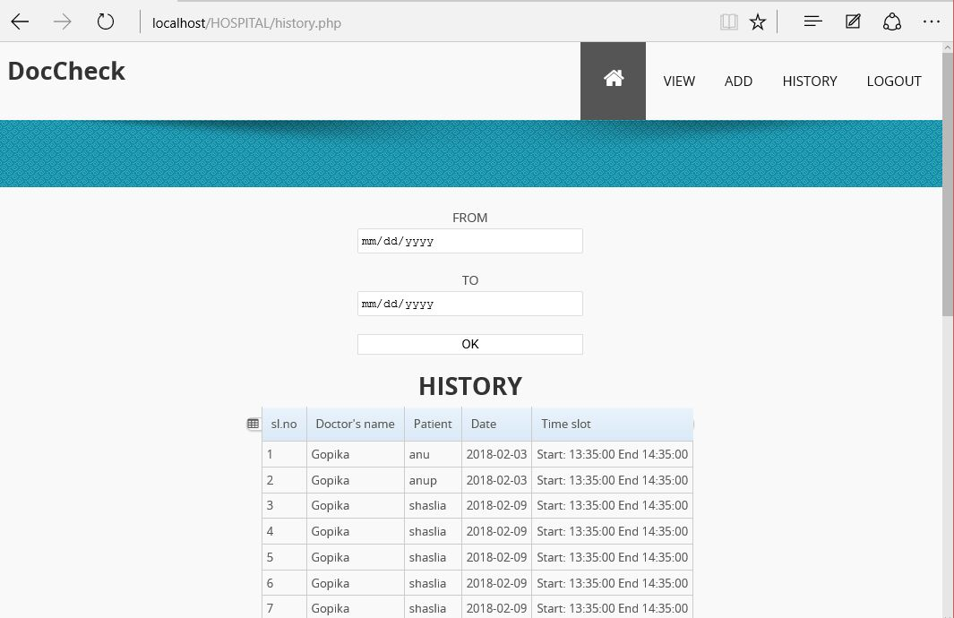

**ANDROID INTERFACE**

**SET IP LOGIN**

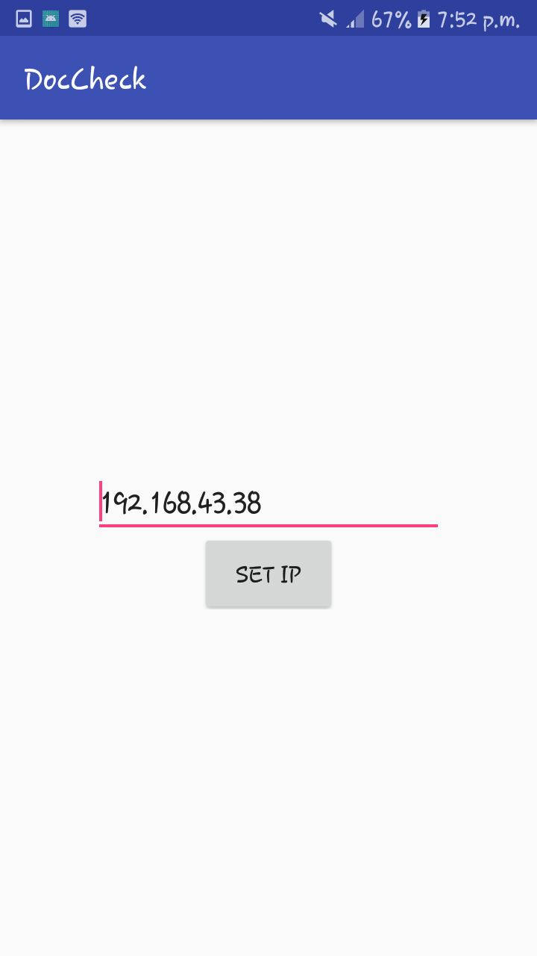 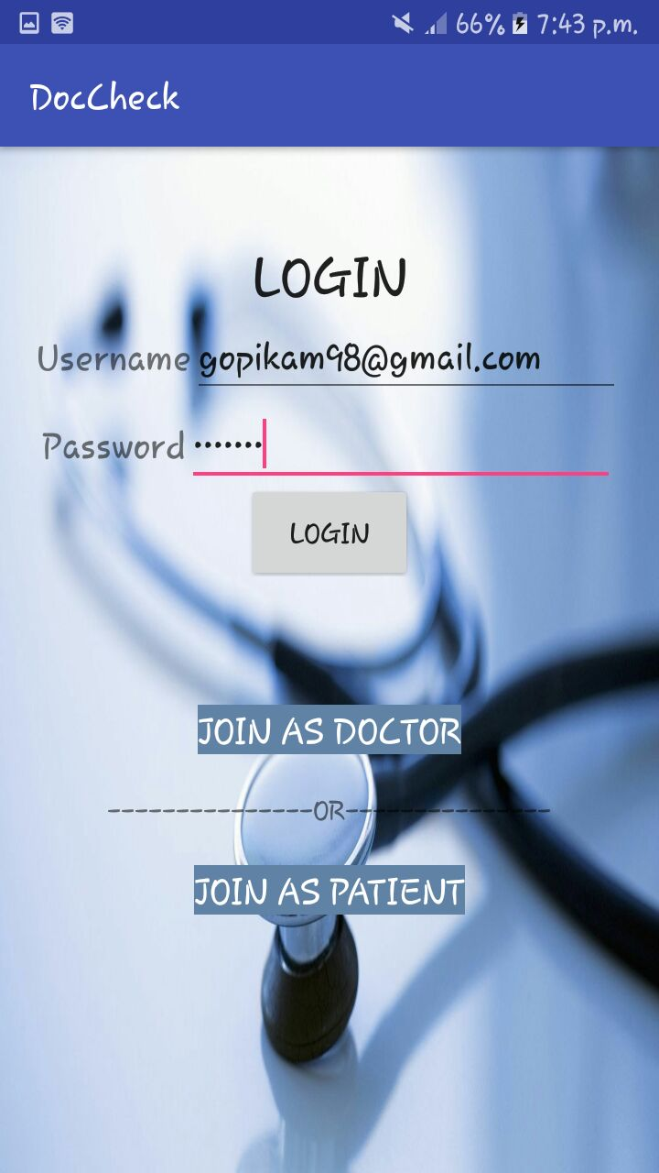

**REGISTRATION DOCOR’S HOMEPAGE**

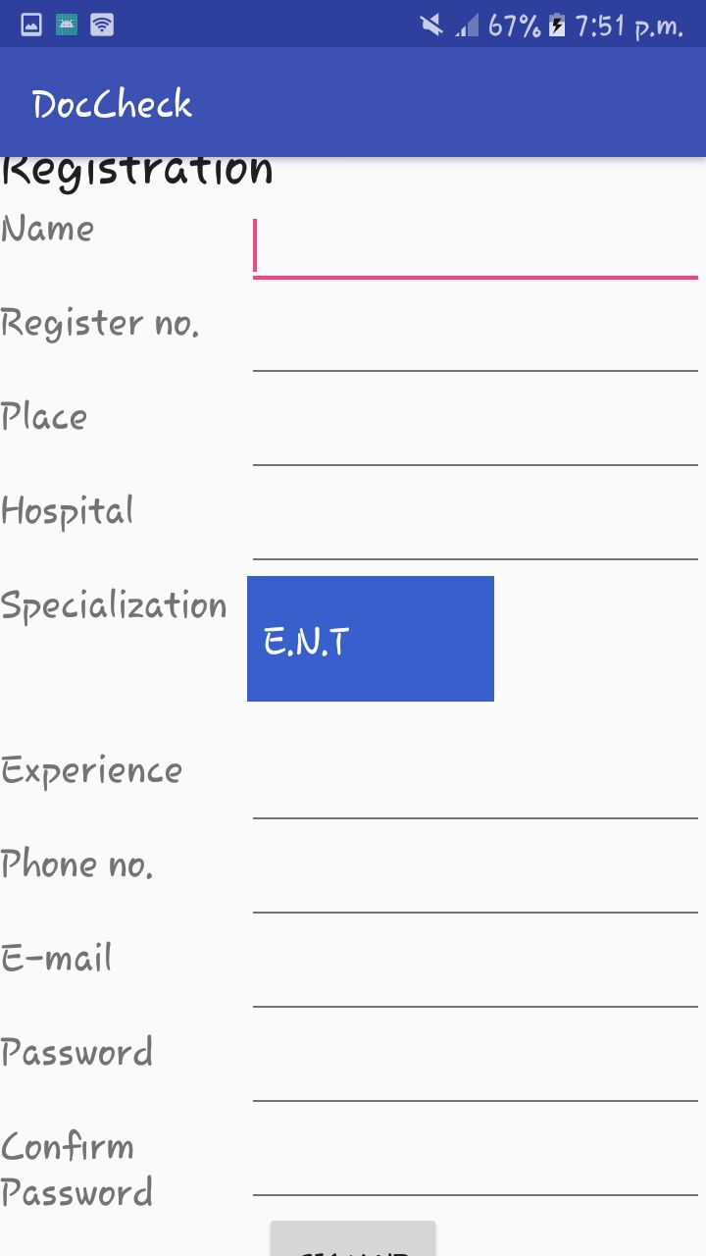 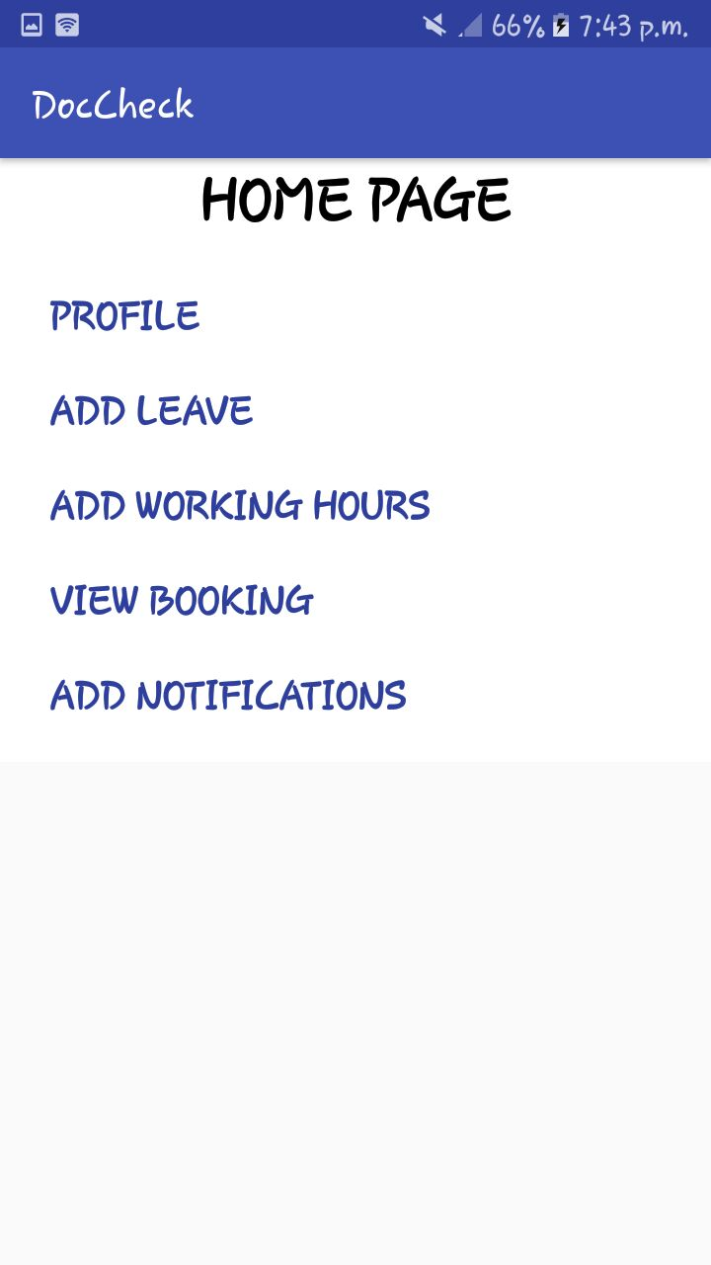

**PROFILE EDIT PROFILE**

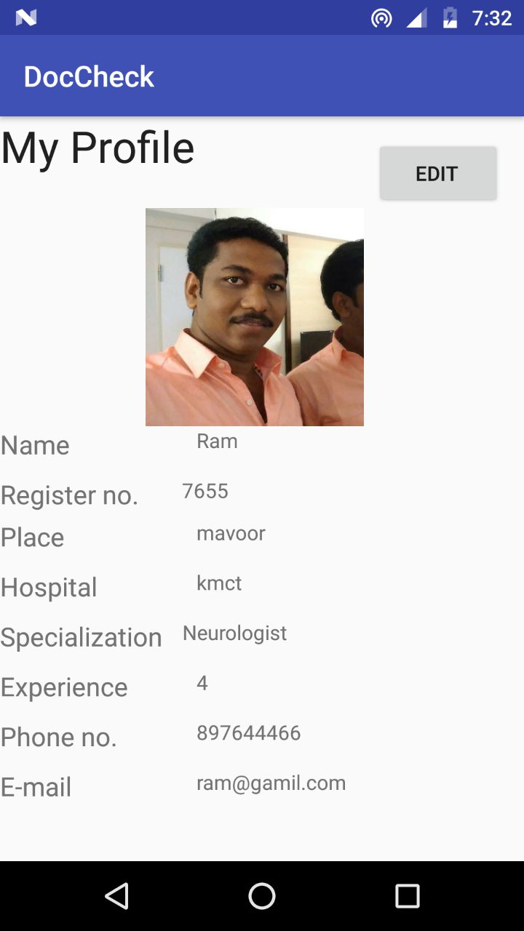 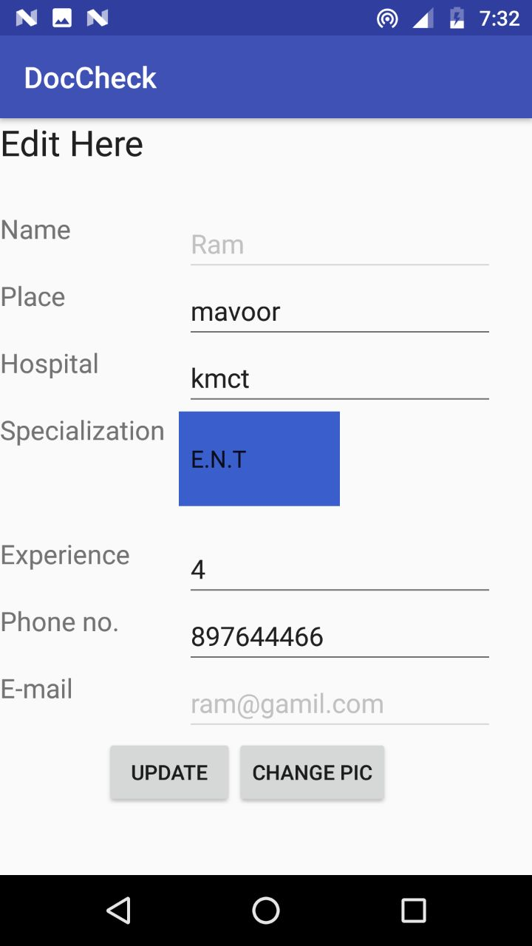

**EDIT PROFILE PIC ADD LEAVE**  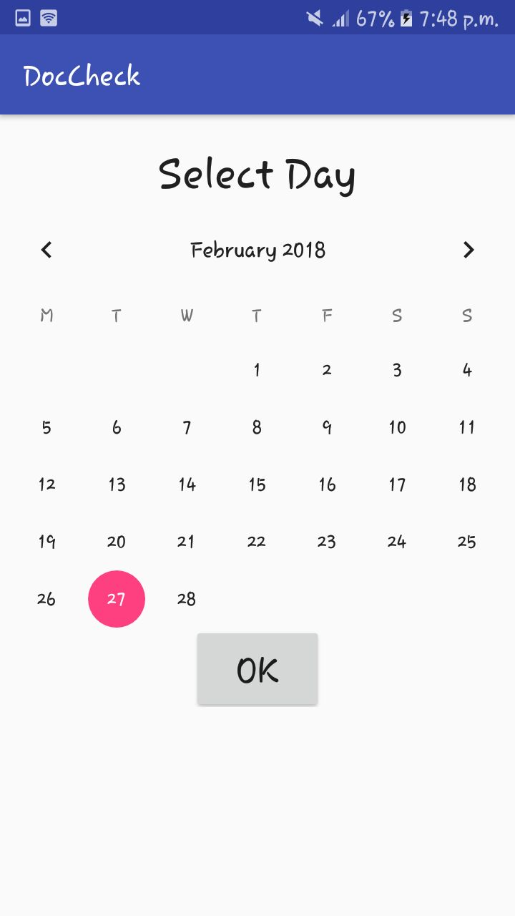

**ADD WORKING HOURS**

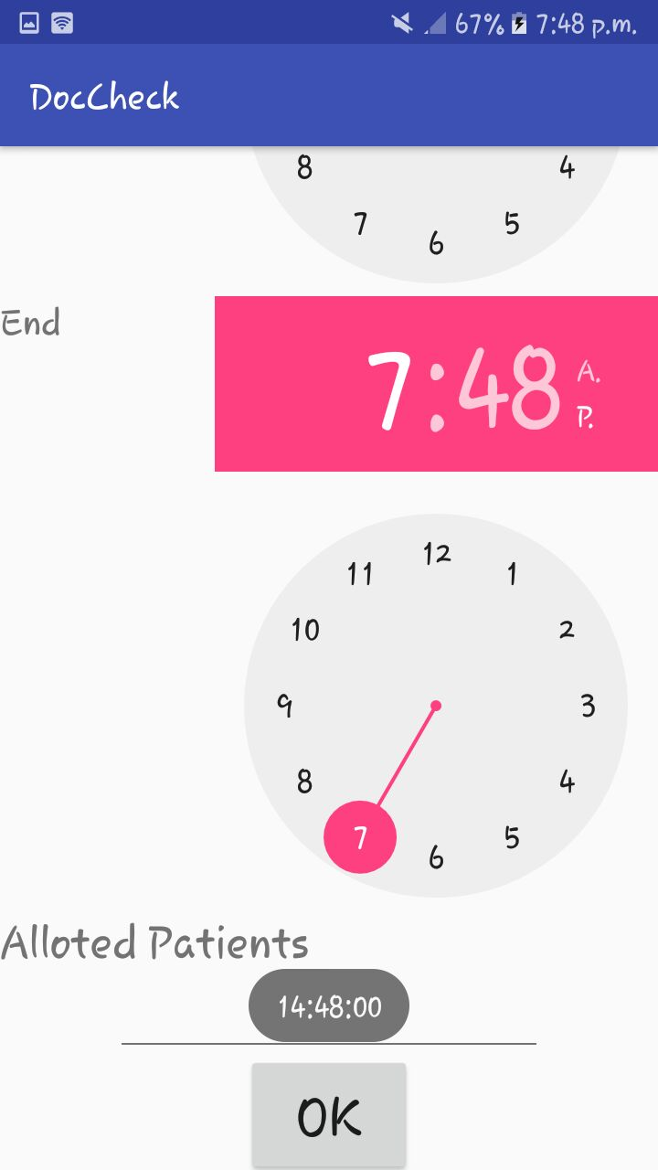 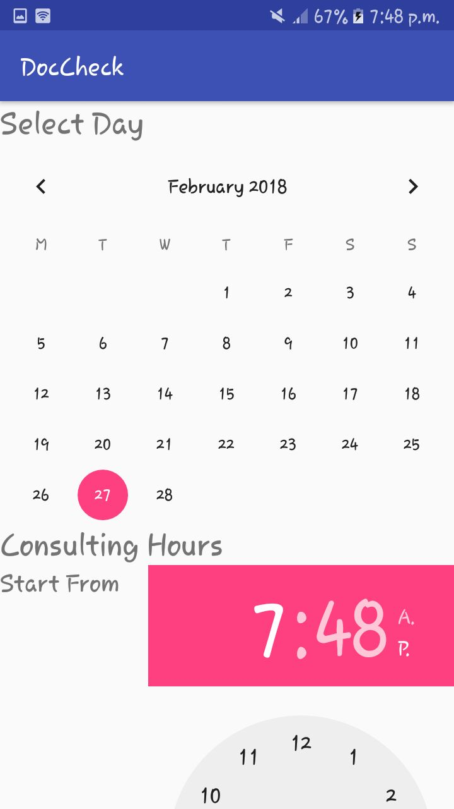

**VIEW BOOKING ADD NOTIFICATIONS**

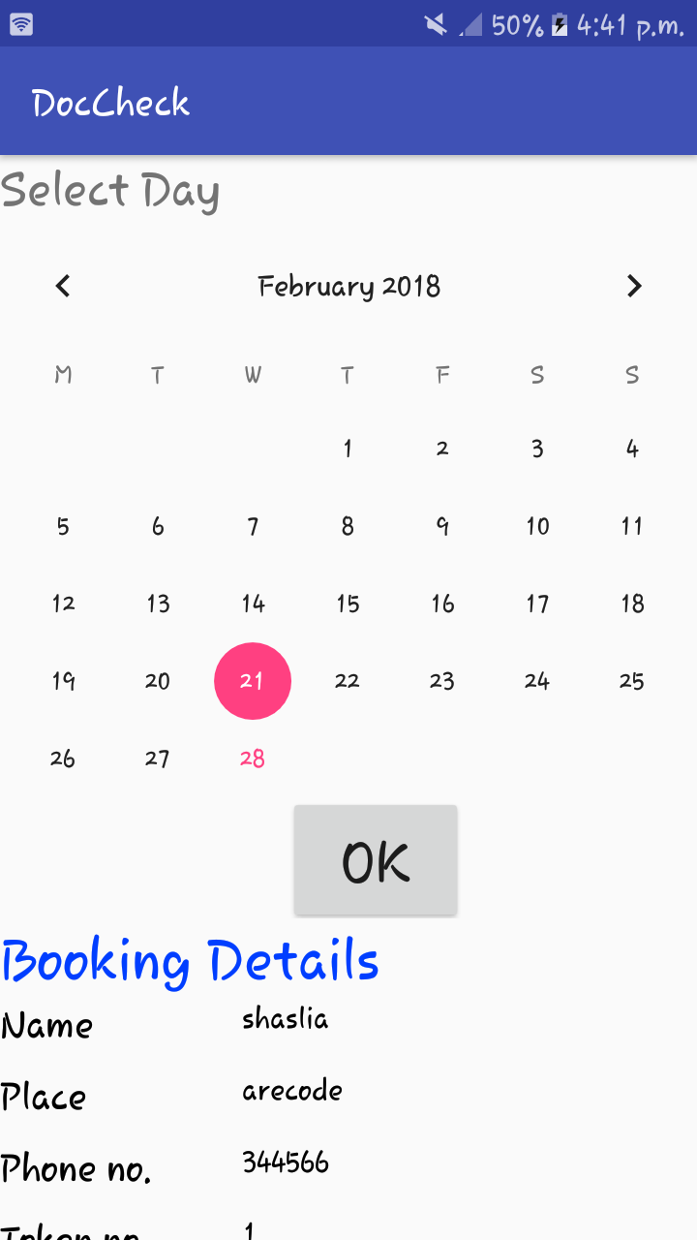 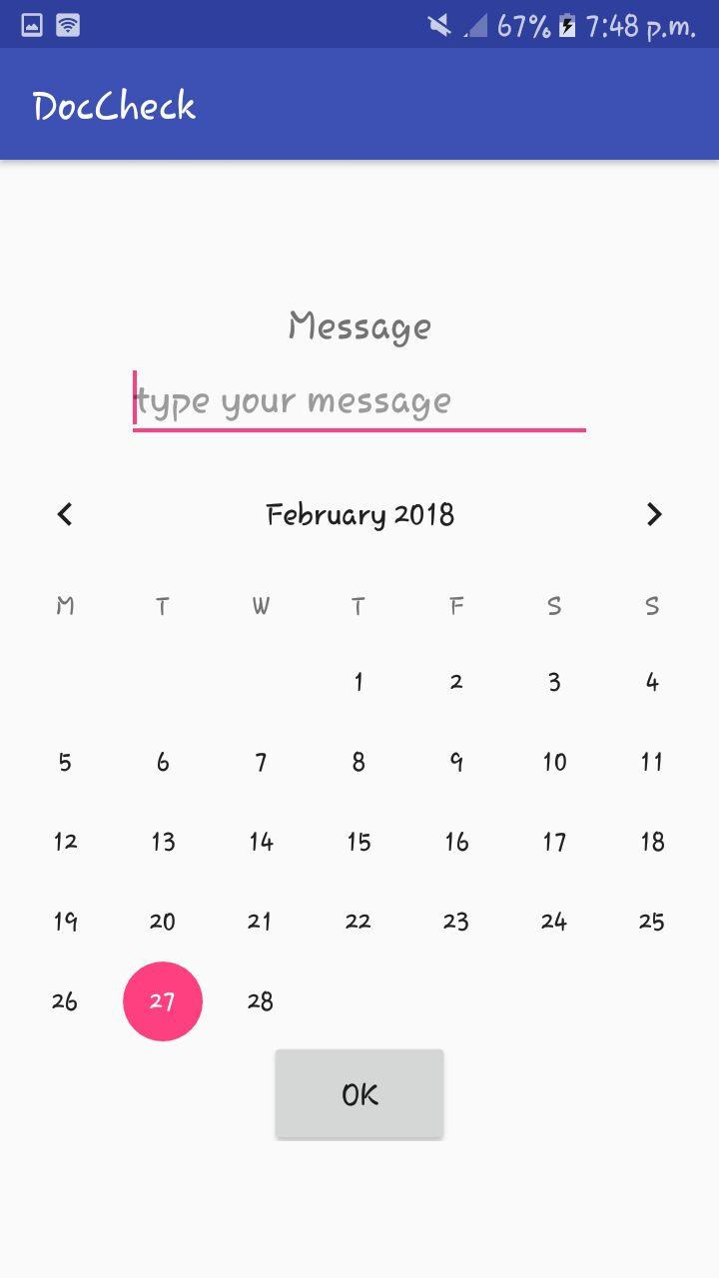

**PATIENT’S HOMEPAGE FIND MY DOCTOR**

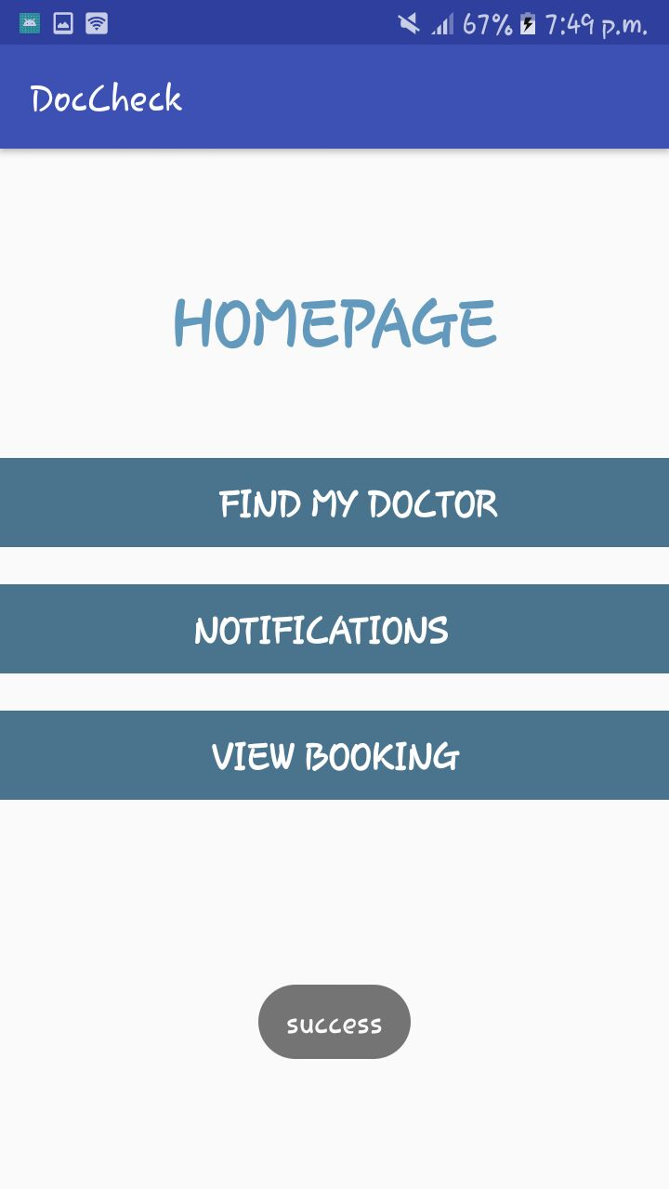 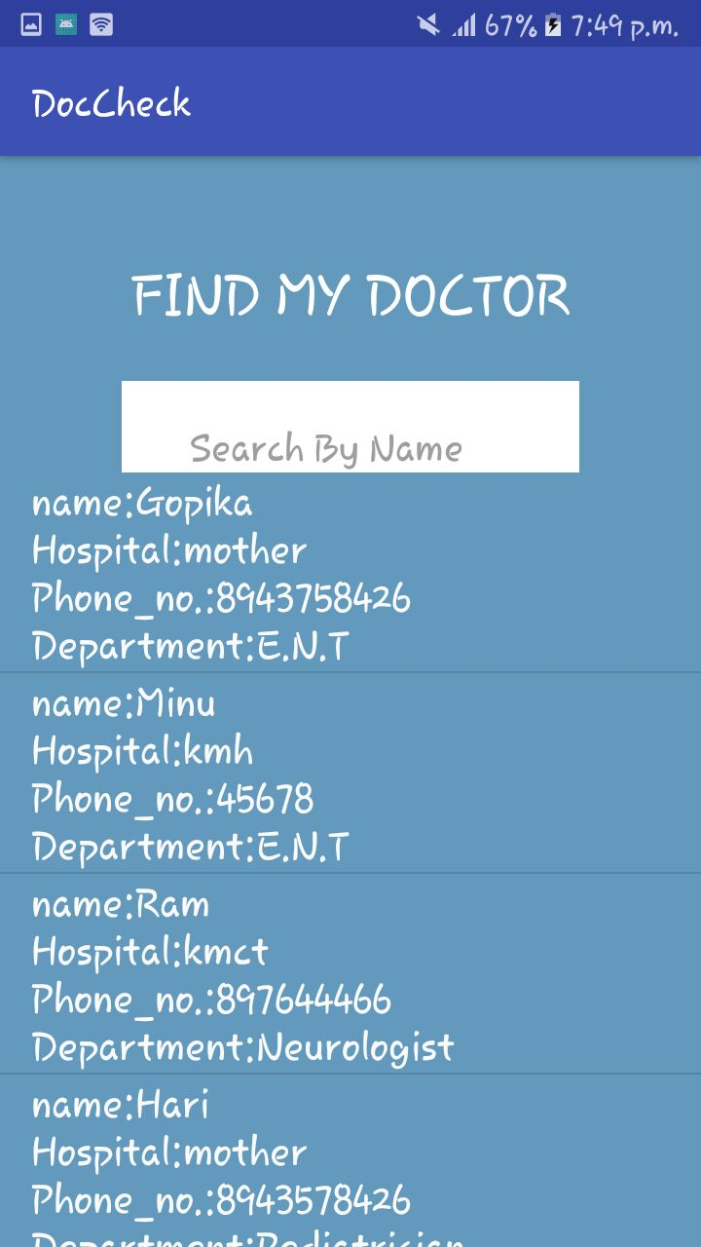

**DOCTOR PROFILE BOOKING**

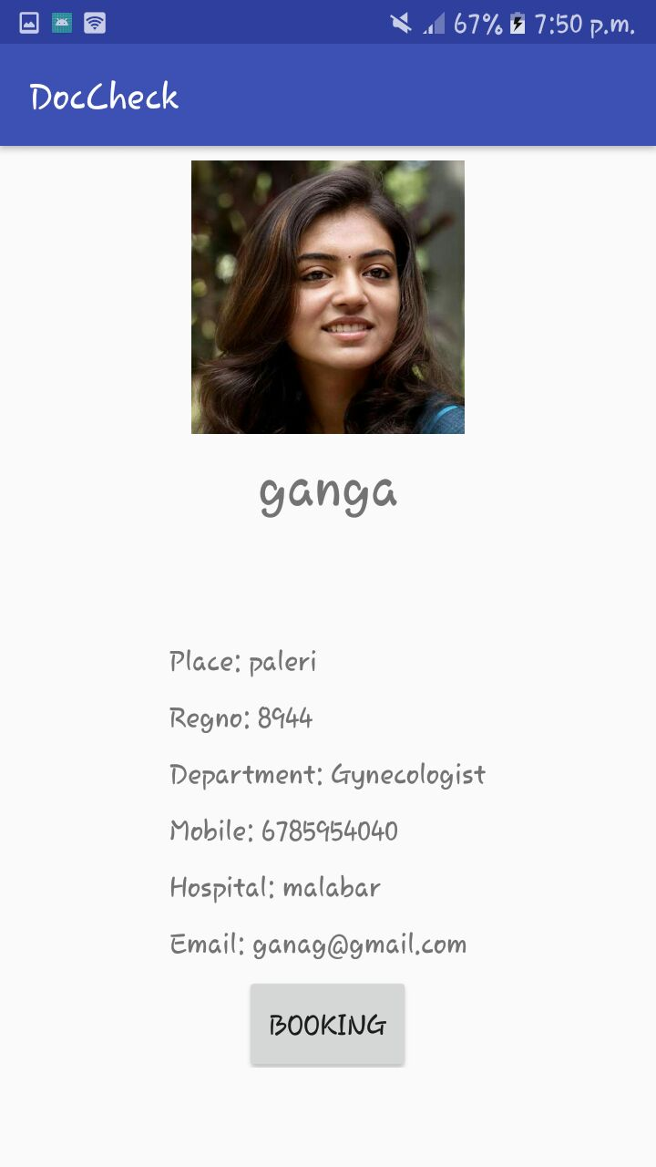 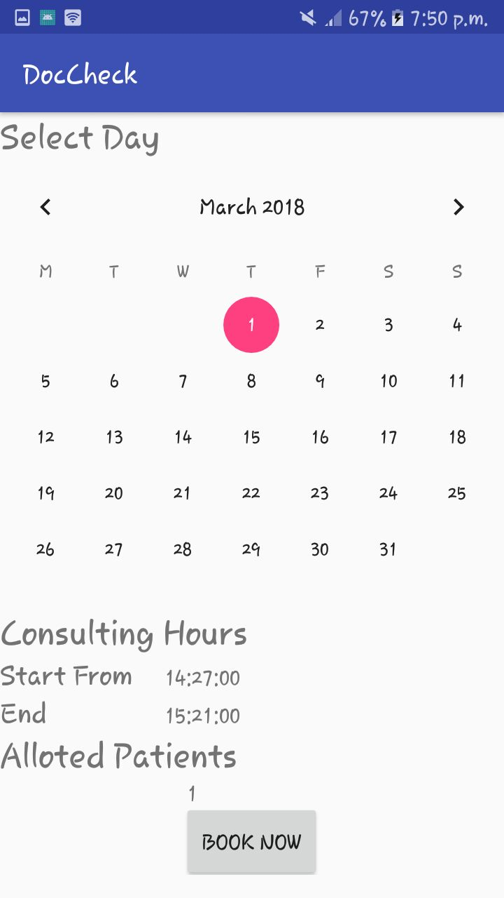

**BOOKING NOTIFICATION**

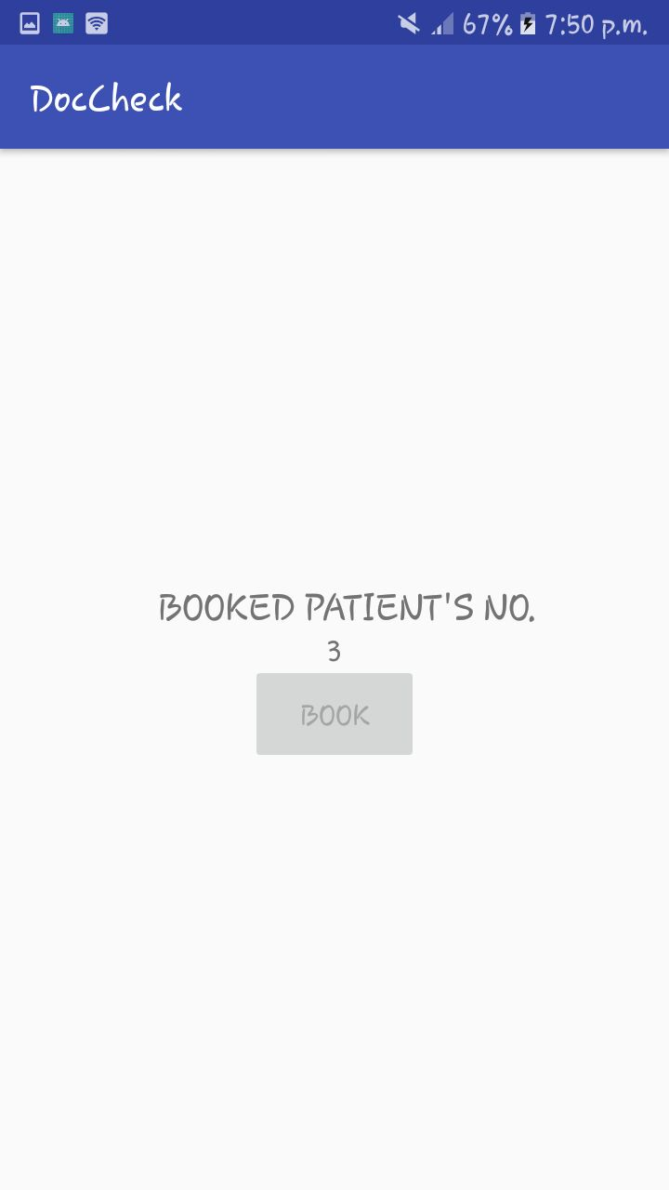 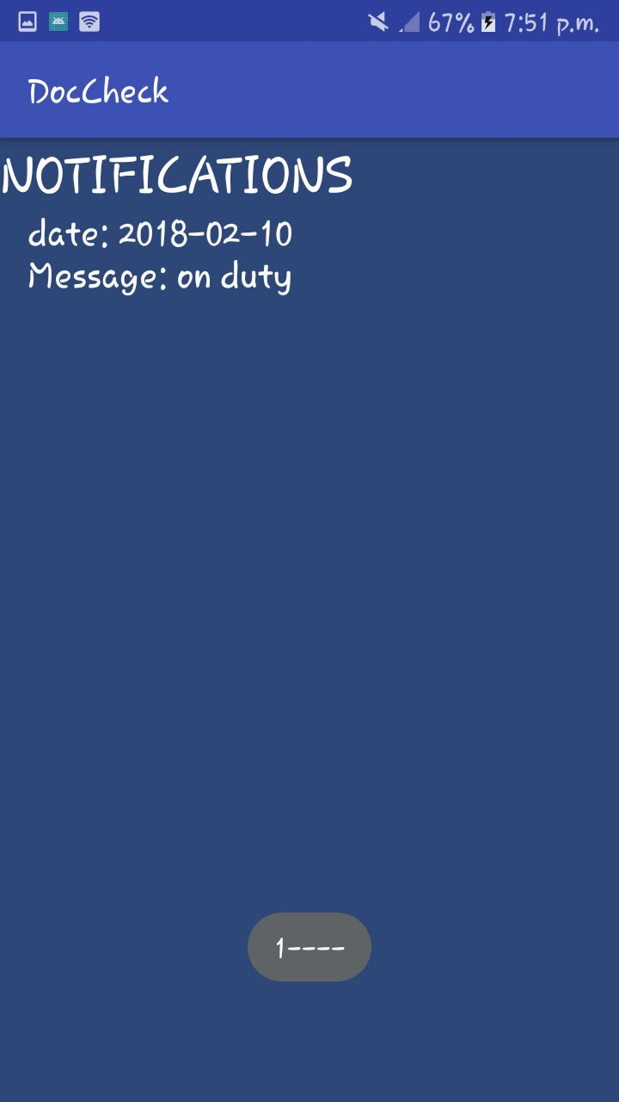

**VIEW BOOKING**

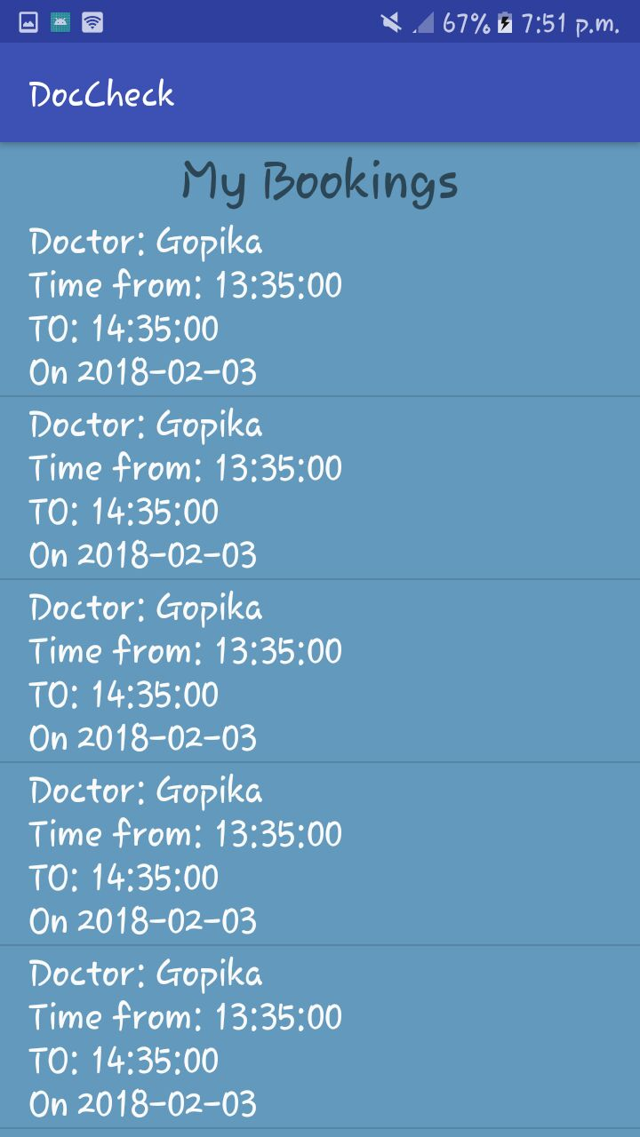

**7. CONCLUSION**

The automation of the existing system is done using the proposed system. Large amount of data can be stored. Fast retrieval and accuracy will be the major benefits of the system. More over maximum user satisfaction is obtained as they can access the doctor details and as per availability can book online. An Instant notification to the user as per availability status is another advantage of this application. It is possible for the users to view their account details by just a login. Both doctors and patients login are provided in a single screen.

**DIRECTION FOR FUTURE ENHANCEMENT**

While developing the system a conscious effort has been made to create and develop a software package, making use of available tools, techniques and resources-that would generate a proper system.

While making the system, an eye has been kept on making it as user friendly, as cost-effective and as flexible as possible. As any user and will adequately meet his/her needs. As in case any system development process where there are a number of shortcomings, there have been some shortcomings in the development of this system also. Then project is still under modification.

Database for different product range and storage can be provided. Multilingual support can be provided so that it can be understood by persons of any language. More graphics can be added to make it more users friendly and understandable manage and backup versions of document online.

**DocCheck**

A main project report submitted in partial fulfilment of the requirement for the award of the degree of

Bachelor of Computer Science

of

University of Calicut

By

**Amina Minusha**

**Reg.no. MEAPSCS024**



Sullamussalam Science College, Areacode

Ugrapuram(P.O), Malappuram-673639

**DocCheck**

A main project report submitted in partial fulfilment of the requirement for the award of the degree of

Bachelor of Computer Science

Of

University of Calicut

By

**Gopika . M**

**Reg.no. MEAPSCS020**



Sullamussalam Science College, Areacode

Ugrapuram(P.O), Malappuram-673639

**DocCheck**

A main project report submitted in partial fulfilment of the requirement for the award of the degree of

Bachelor of Computer Science

Of

University of Calicut

By

**Shasliya .V**

**Reg.no. MEAPSCS022**



Sullamussalam Science College, Areacode

Ugrapuram(P.O), Malappuram-673639

**DocCheck**

A main project report submitted in partial fulfilment of the requirement for the award of the degree of

Bachelor of Computer Science

Of

University of Calicut

By

**Shifana .E**

**Reg.no. MEAPSCS023**



Sullamussalam Science College, Areacode

Ugrapuram(P.O), Malappuram-673639